ACM ASSIGNMENT

1. The Oil Spill Problem.

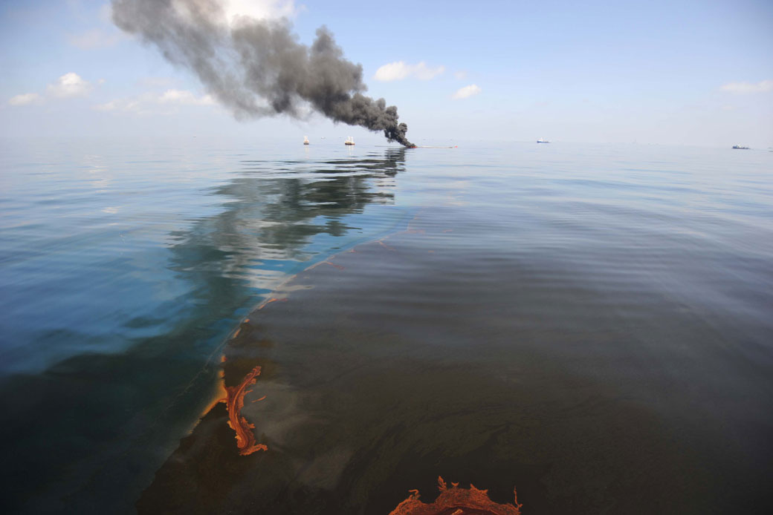

The oil spill has occurred in the Mangalore coastline. Oil spills produce many problems. These include:

1. Economic problems:   
   Direct economic problems are wastage of a lot of oil, enormous amount of resources to clean up the oil.  
   Indirect problems are loss of livelihood for local people as fisheries are closed leading to spike in the prices of staple diet of people of coastal region.  
   Tourism of the region is affected causing long term impact in the livelihood of the people.
2. Environmental problem:   
   Oil spilling on the sea causes a damage to natural habitat of the marine ecosystem. These chemicals may further break up into toxic components and cause very harmful effects.  
   Oil spill also causes an immediate fire hazard which releases tons of pollutants in to the air and kill people.  
   Oil generally penetrates into skin of the aquatic animals causing long term damages to the animals and in the food chain further.

There are many ways of cleaning an oil spill. Considering Mangalore as a tropical region with calm coastline which is highly populated, it isn’t possible to **in situ burn the oil**. Usage of **boom and** **sorbents** is the most effective and efficient solution in the given condition since we need the oil spill to be cleaned up quickly so that livelihood of locals is not interrupted.

Some of the ways include:

1. **Booms** need to be put down as soon as possible to contain the spill region of the oil. **Skirts and Freeboards** are to be put in place for splashing or squeezing under the booms and escaping. 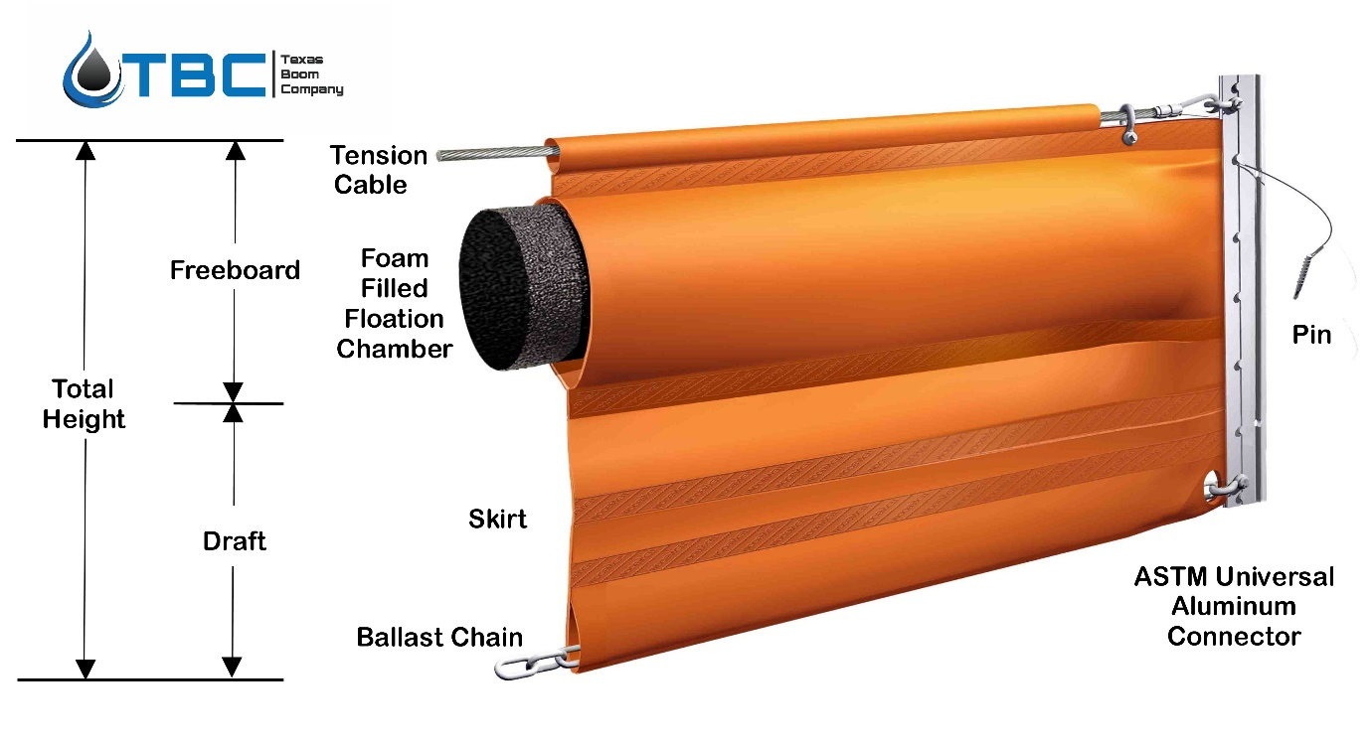
2. Since Coconut is widely grown in Mangalore region, Coconut husk can be used to adsorb the oil spill. Though scientifically Coconut husk is not the most efficient way but coconut has the ability to retain the oil which can be reclaimed from it. Scientific studies on coconut husk have shown up to 83% recovery of oil from the husk.

This method like many others has both pros and cons

Pros: Cheap, environment friendly, effective, oil recovery possible

Cons: Not extremely efficient, needs to be implemented as quick as possible for higher efficiency.

**METALLURGY AND MATERIALS:**

**Q2.** A phase in a material is homogenous and mechanically inseperable. There are 5 main types of binary phase reactions:

1. Eutectic Reaction:

This type of phase reaction occurs when both components have almost equal melting point. It is denoted by

**L→α+β**

Its examples include: Cu-Ni

The phase diagram is given as:

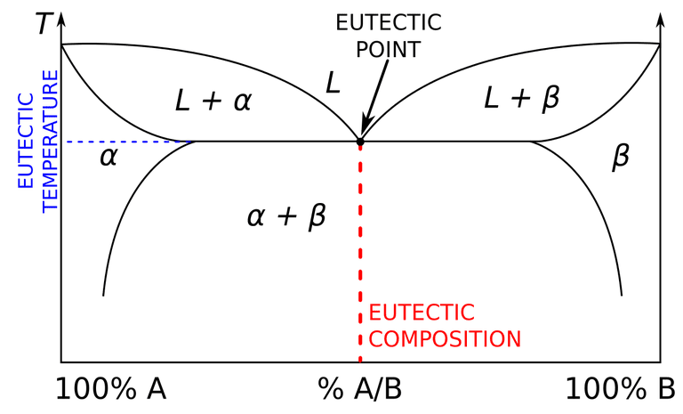

2. Eutectoid Reaction:

When one solid phase converts into two phases it is known as eutectoid invariant reaction. For ex. Fe-C

**γ→α+β**

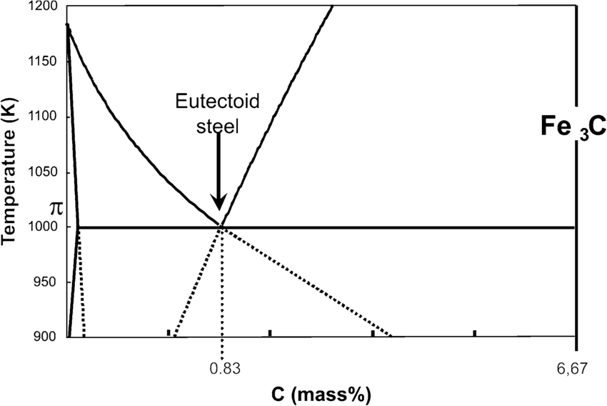

1. Peritectic Reaction:  
   When two components which have a large difference in melting point mix, this kind of invariant reaction occurs.

**L+α→β**

Its example include: Pt-Ag

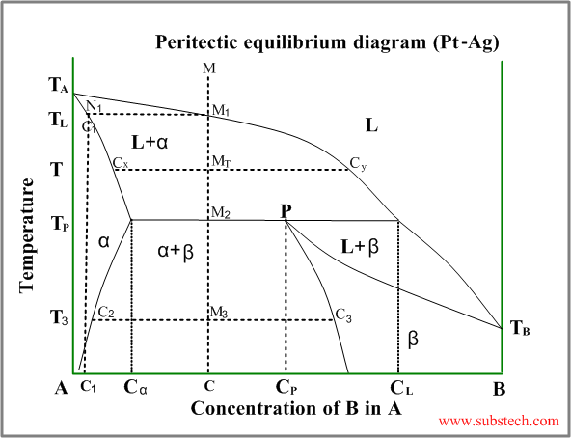

1. Peritectoid Reaction:  
   When two solid phases combine to form one solid phase, it is known as peritectoid invariant reaction.   
    **α+β → γ**Its examples include Fe-C phase diagram.   
    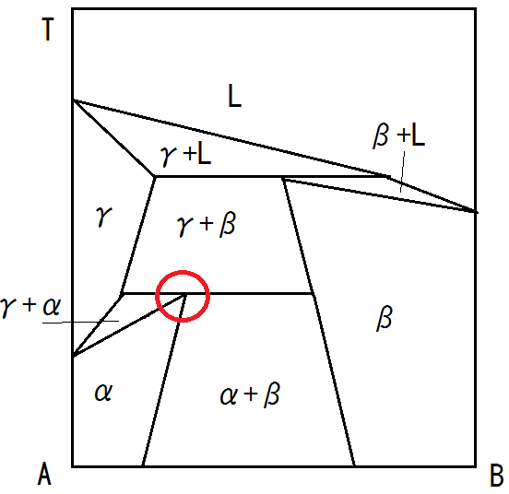
2. Monotectic Reaction:  
   When a liquid phase cools down to another liquid phase and a solid phase, the reaction is known as monotectic reaction.  
    **L1→L2 + γ**

Its examples include Pb-Cu system at 9550C and 36% composition

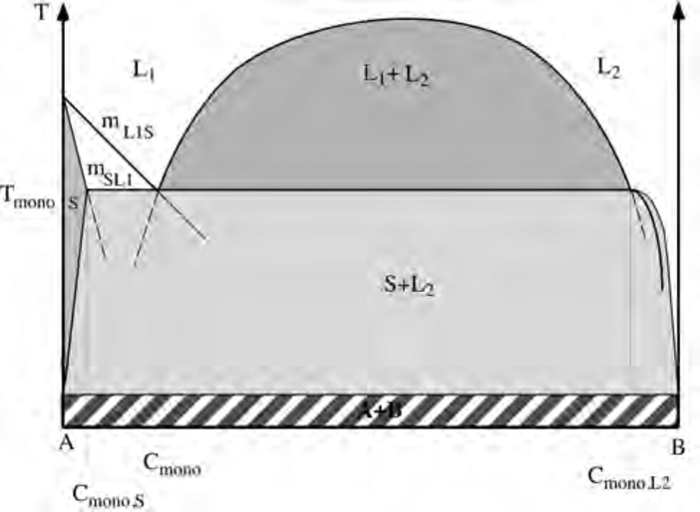

**Q3**. It is found out that during plastic deformation crystalline order is not lost. There are two mechanisms which have been associated with plastic deformation. These are slip and twinning. Slip mechanism is that unit cells don’t deform but slide over one another. This causes slip lines to come to the surface. However the Critical Resolved Shear Stress is still of many orders higher than the Yield Stress of the material. The main reason for this is because plastic deformations occur due to dislocation motion. The dislocations when come to surface they form a step at the surface equal to Burgers vector which can be seen as localised bands. Furthermore the **Frank-Read** sources of dislocations generate more dislocations and lead to more slip lines on the surface.  
One of the ways of reducing this is by annealing the crystal. A well annealed crystal has stress and dislocation density of many orders less than a cold worked crystal. Another way of reducing these is to convert these dislocations into sessile dislocations. This is known as strain hardening. Solid solutions, for ex Carbon can also act as an impediment to dislocation motion. Grain boundaries act as obstacle to dislocation motion. Grain size reduction can therefore lead to hardening of the crystal